CloneZilla Image Restore Guide:

1. Follow steps 1 through 10 of the image creation guide.
2. You should now be on this screen:

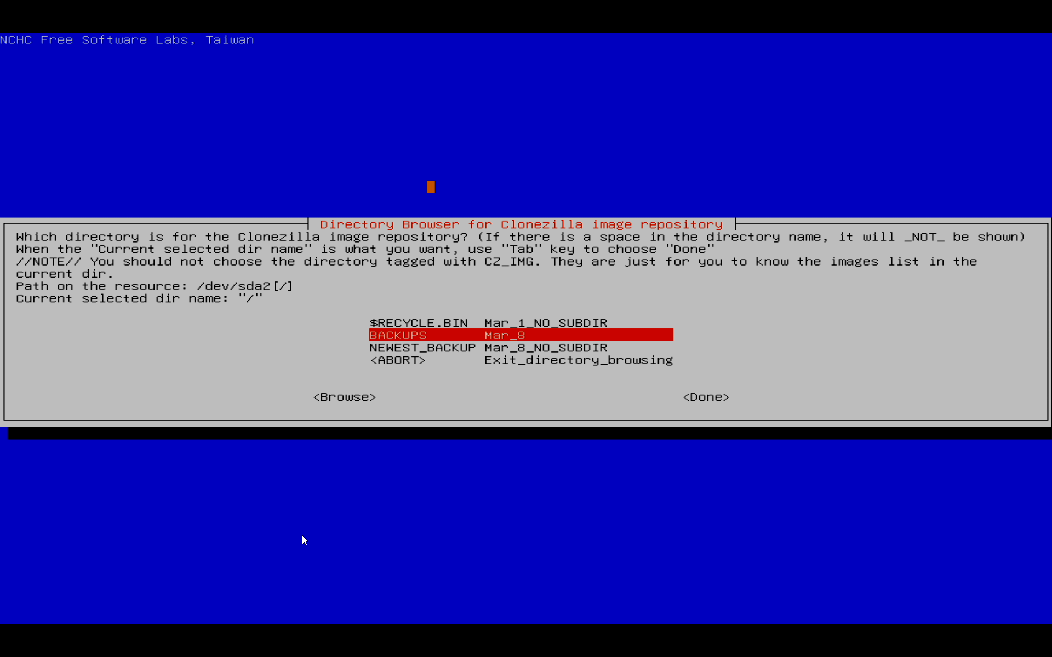
Choose BACKUPS and press enter.
3. Choose the area that the exhibit you are restoring was in when its backup was made.

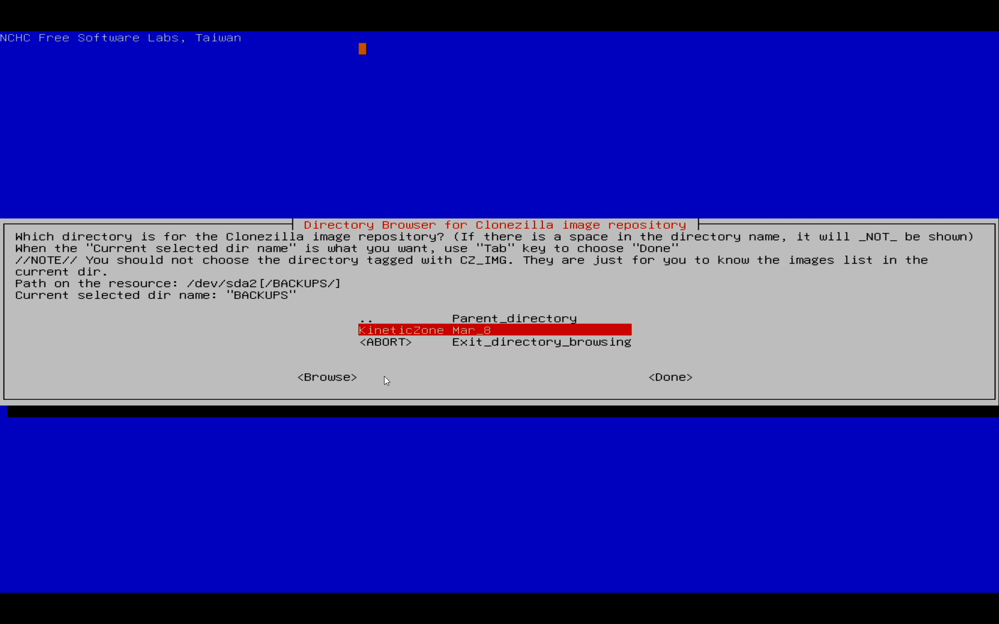
4. Once you can see the actual folder with the image, choose done:

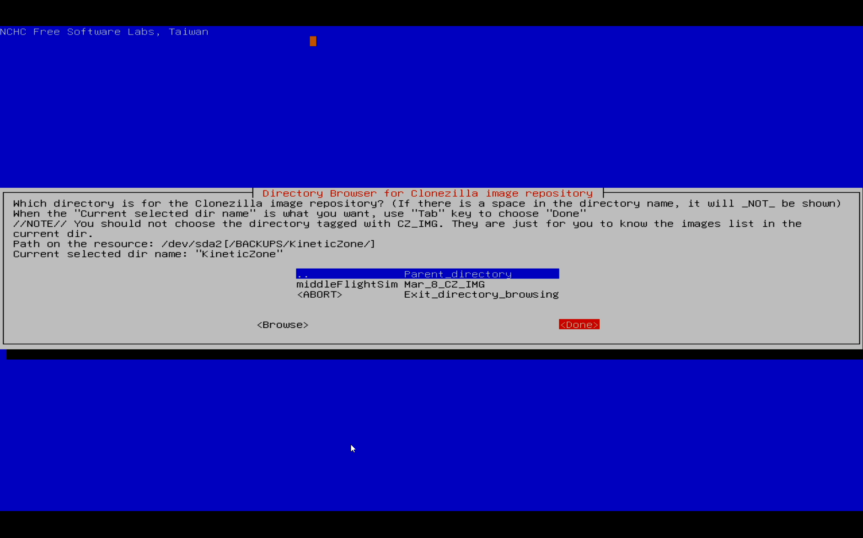
5. Press enter
6. Choose beginner
7. Choose restoredisk:
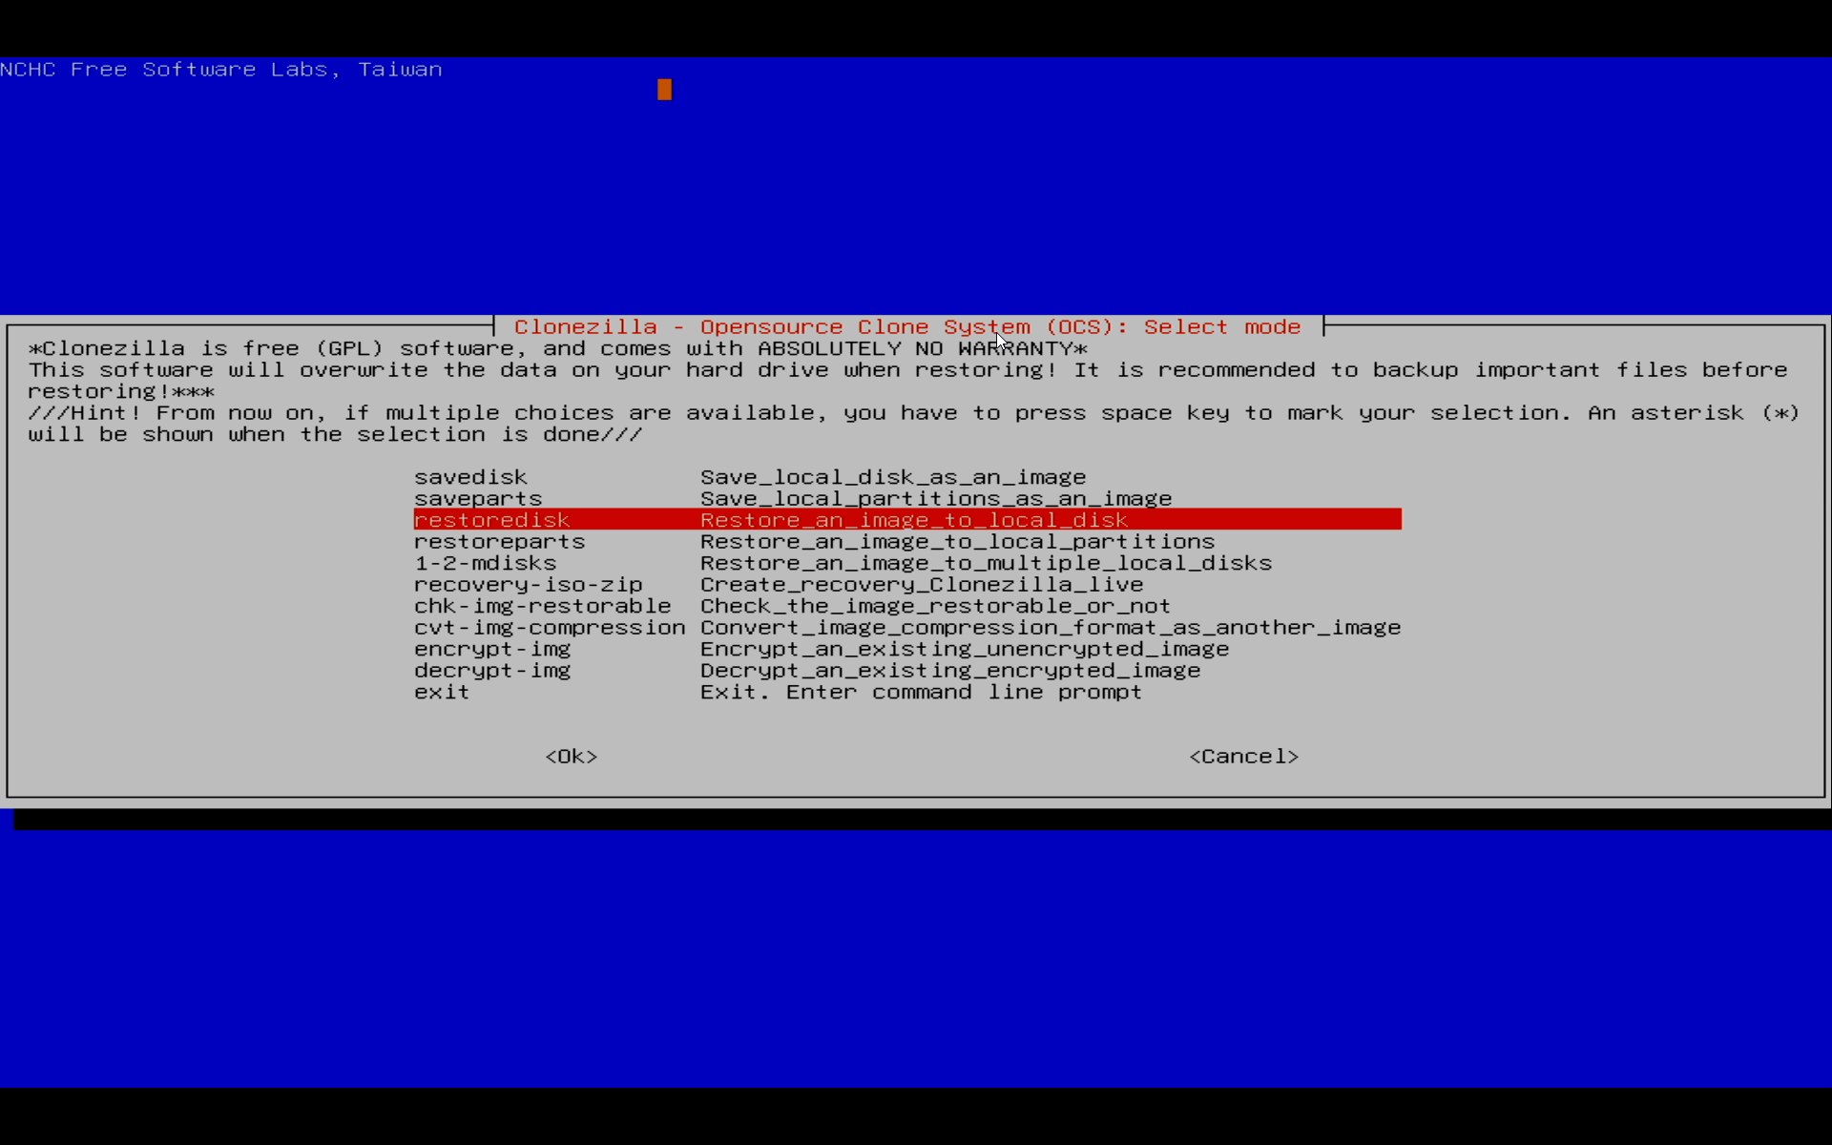
8. Pick the actual backup:
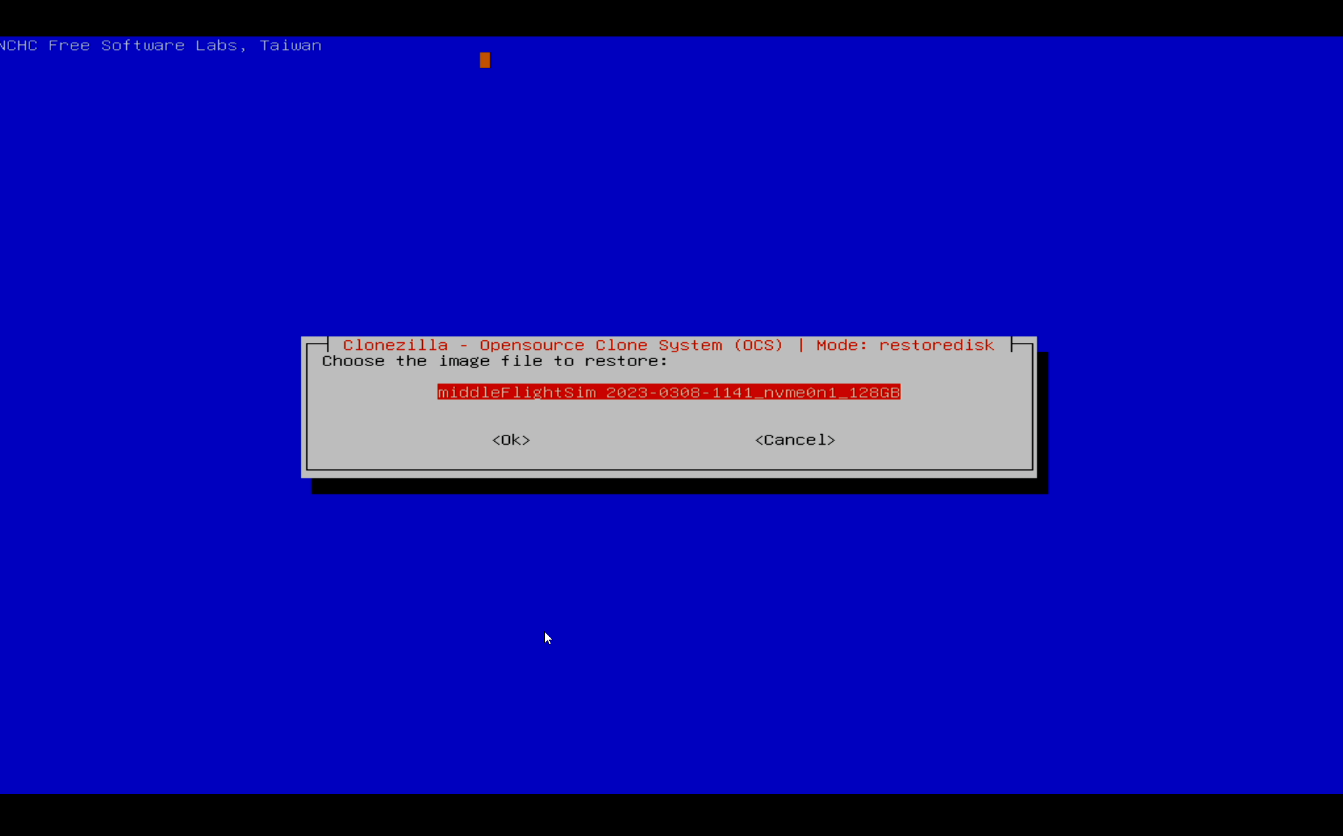
9. Press ok
10. Now you are selecting the internal hard drive in the exhibit to restore the image to:

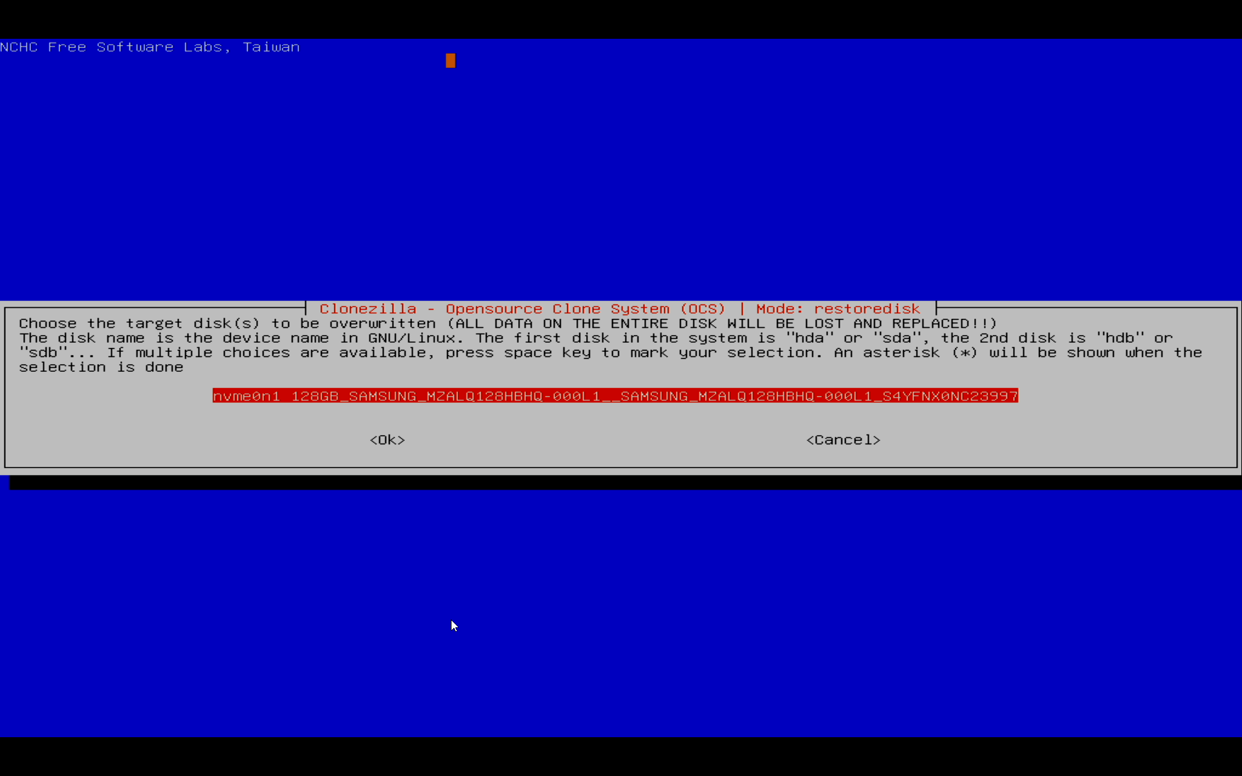
11. It will look different for every exhibit. If multiple are shown BE VERY CAREFUL that you are restoring to the correct internal hard disk. Select the disk to restore to and select ok
12. If you are restoring to a disk that is larger than the original, you can select “create partition table proportionally” but if you are restoring to a disk of the same size as the original, you should select “use the partition table from the image”
The original size should be listed on the same screen as the screenshot for step 8.
13. Choose “No, skip checking the image before restoring”
14. Choose -p choose and press enter, you should get the following message:

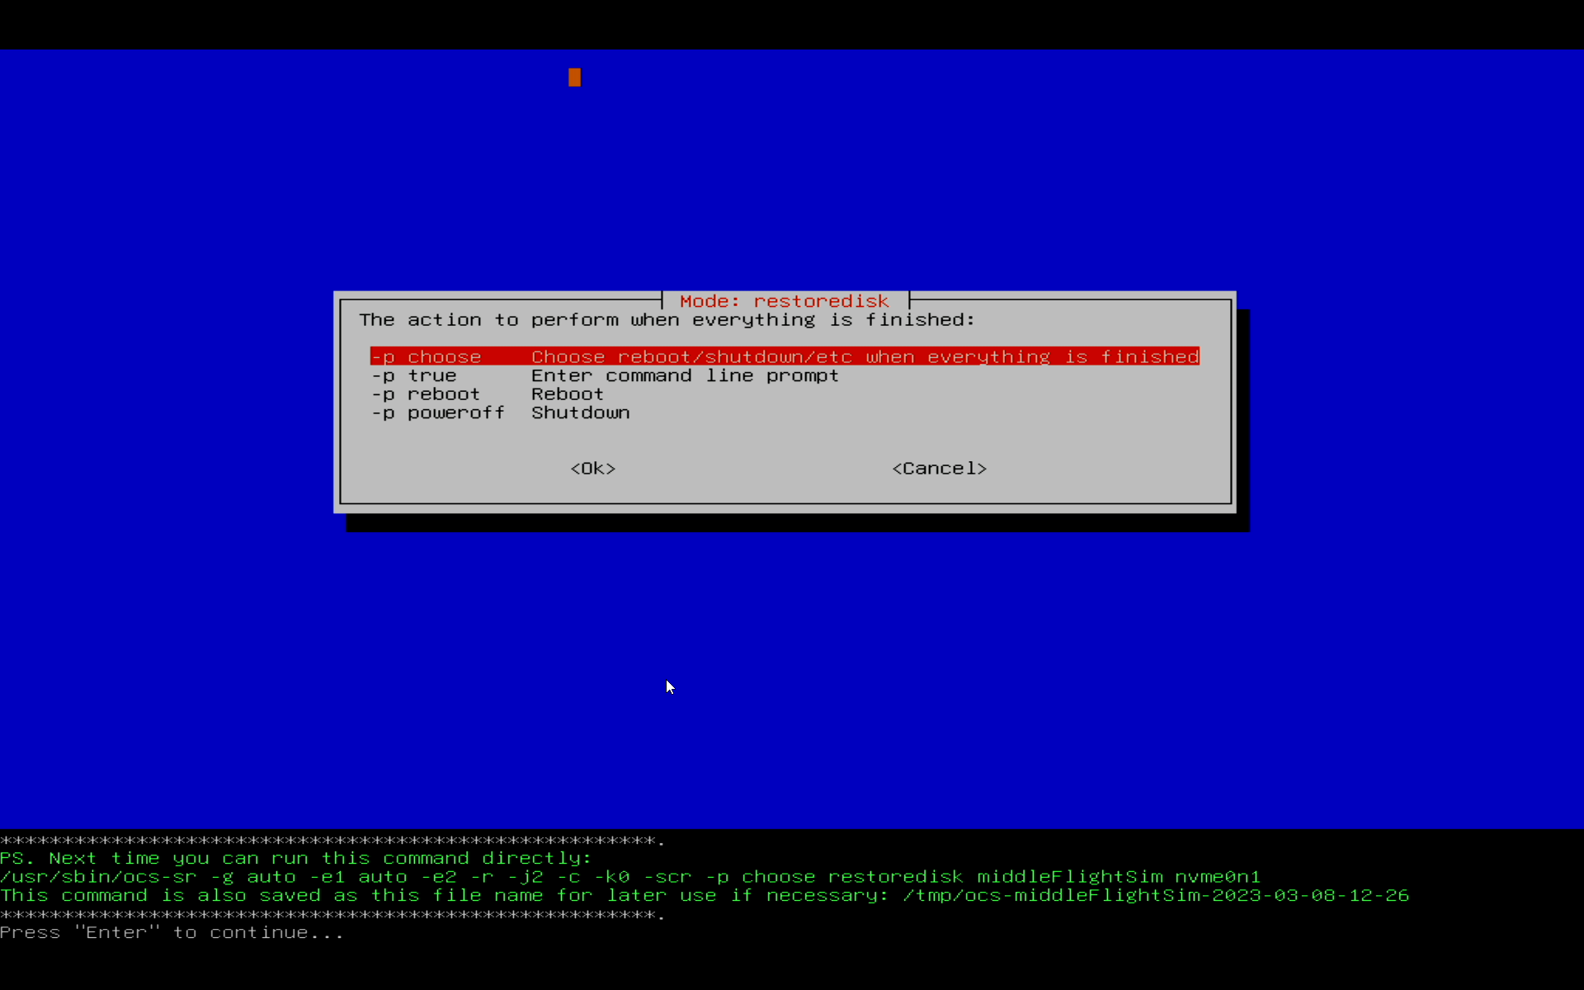
15. Press enter to start the restore.
You should see a message similar to the following:
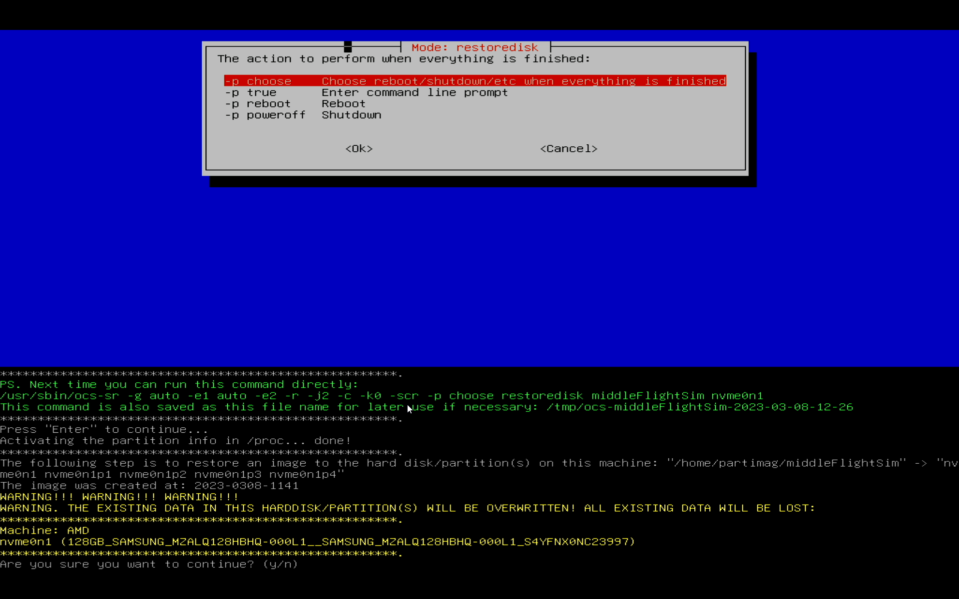
16. Press y and hit enter
17. It will have you confirm again, so press y and then enter
18. It should soon progress to the restore screen, similar to what’s shown below:
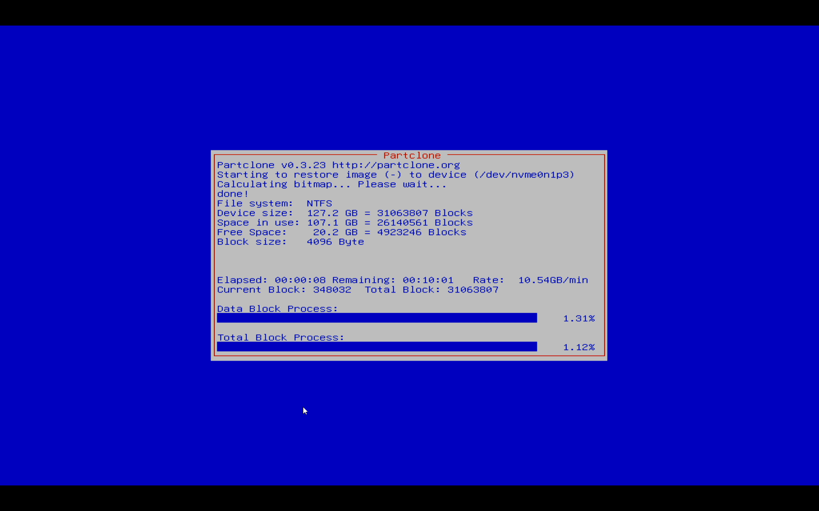
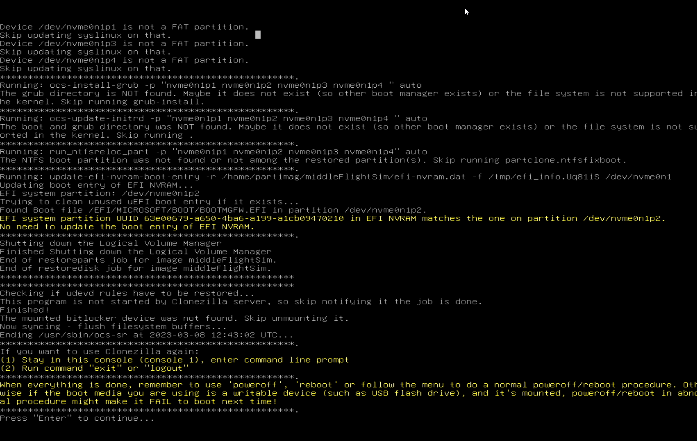
19. You should see this screen when it’s finished:
20. Select poweroff and hit enter.

21. Remove the EXHIBITS BACKUPS HDD and thumbdrive and power back on the computer, it should boot normally.
Note: If you are powering the simulators after a restore make sure to put in the dummy displayport dongle BEFORE booting it back up.

